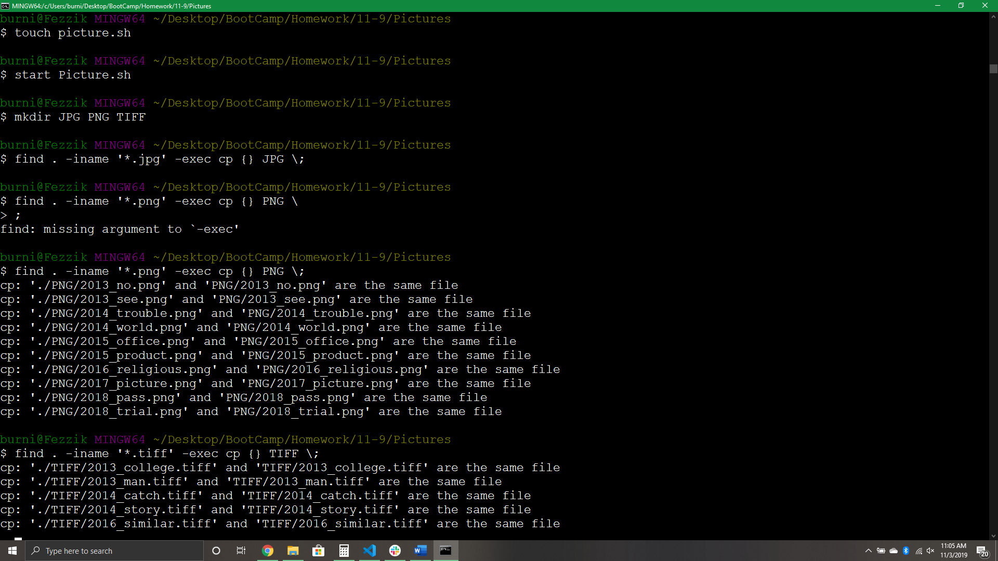

Find all .png’s and copy into PNG Directiory

Find all .tiff’s and copy into TIFF Directiory

Find all .jpg’s and copy into JPG Directiory

Create new directorys

Open the sh file

Create a sh file

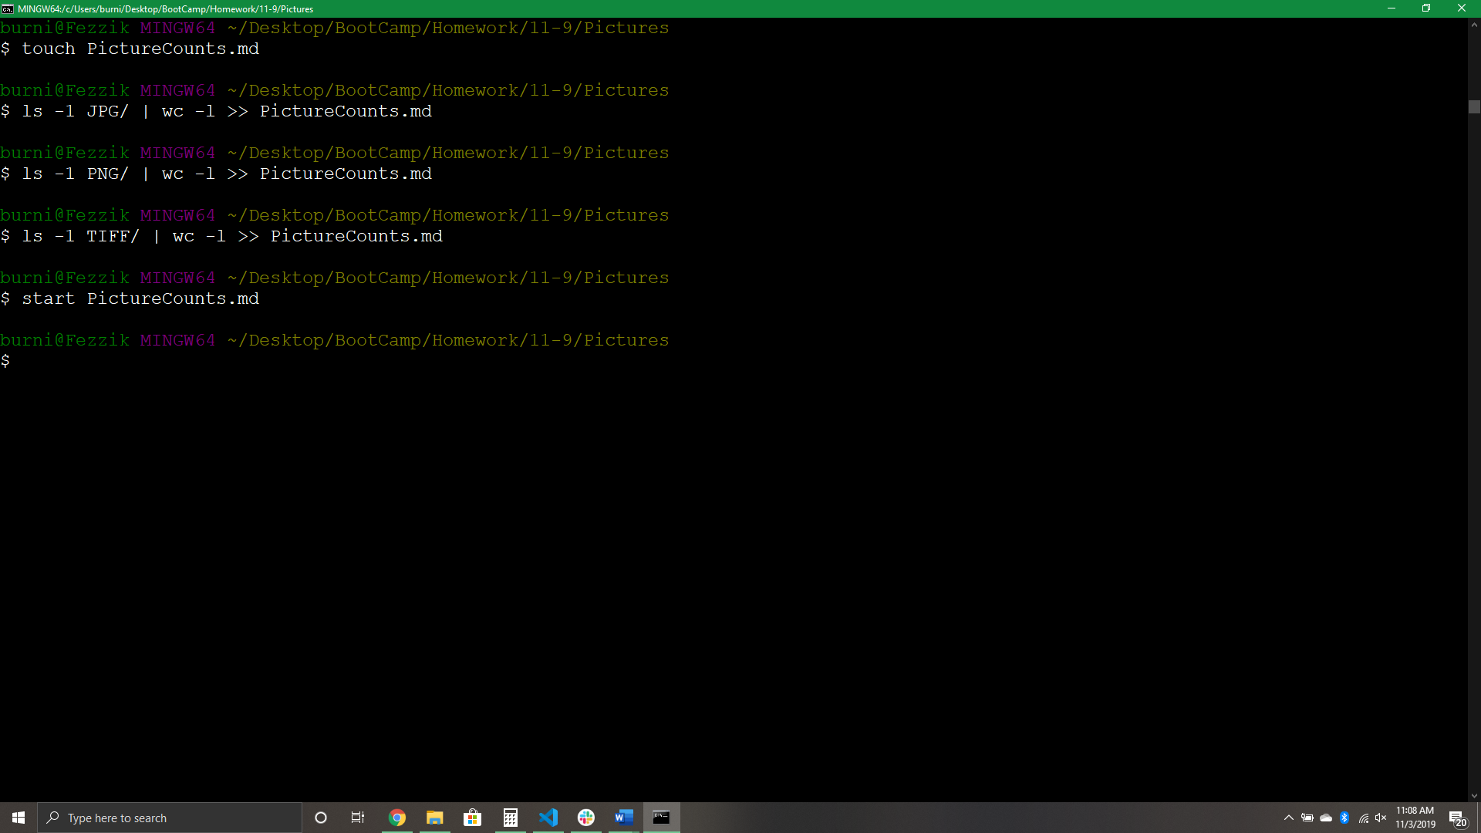

Open the PictureCounts.md file

List all the .tiff’s in the Tiff Directory and print that count into the PictureCounts. md file

List all the .png’s in the PNG Directory and print that count into the PictureCounts. md file

List all the .jpg’s in the JPG Directory and print that count into the PictureCounts. md file

Create the PictureCounts.md file

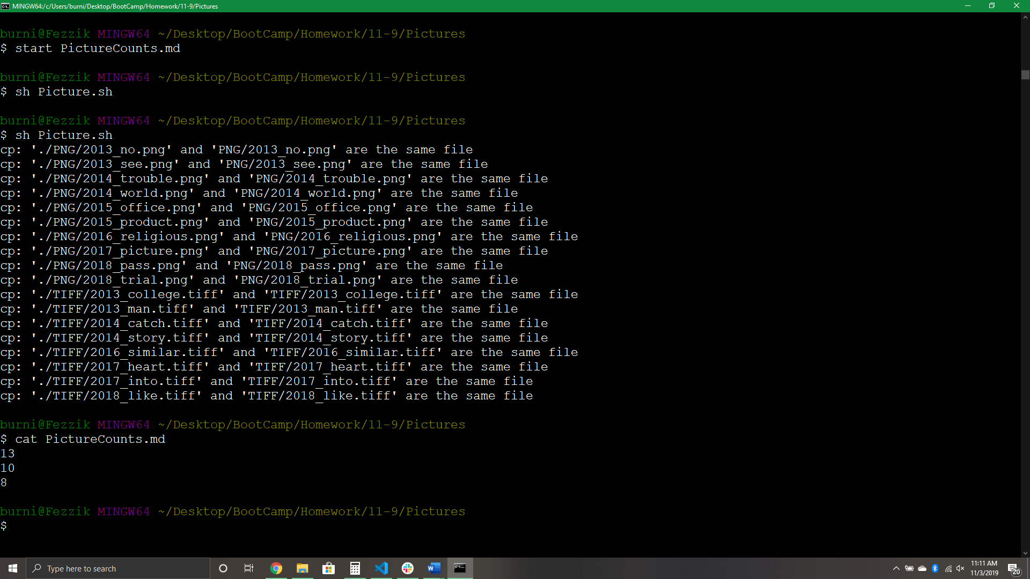 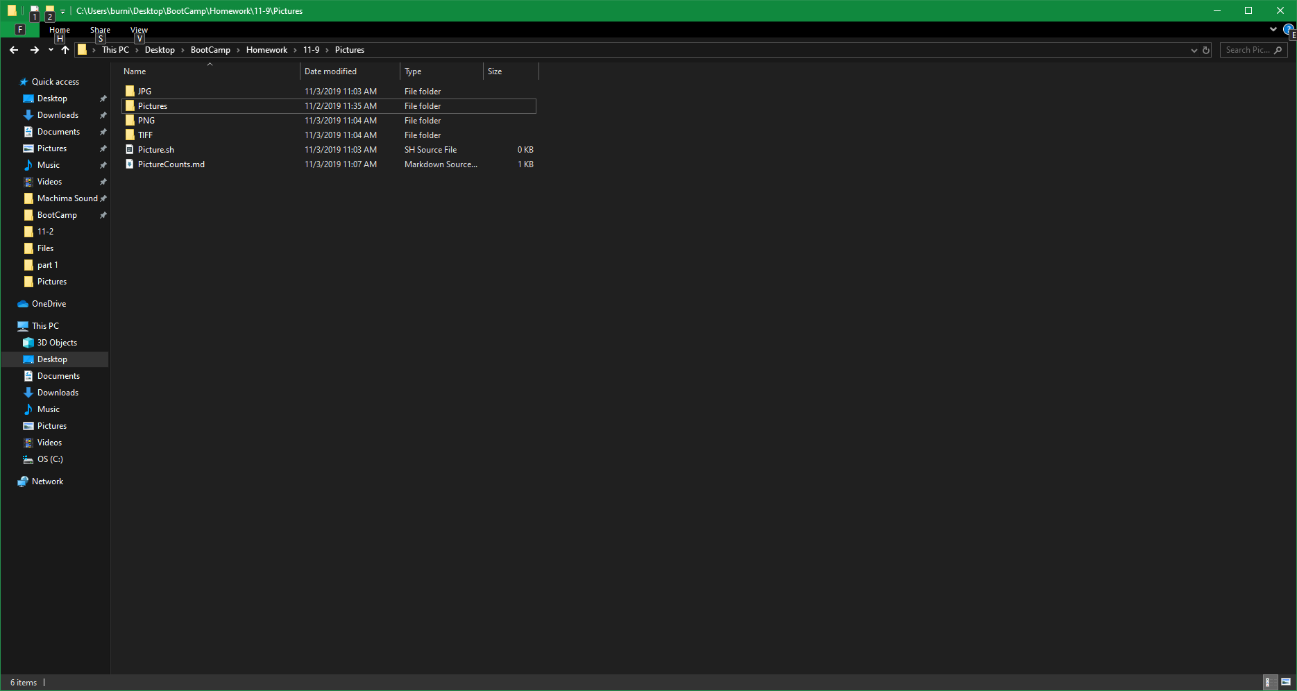 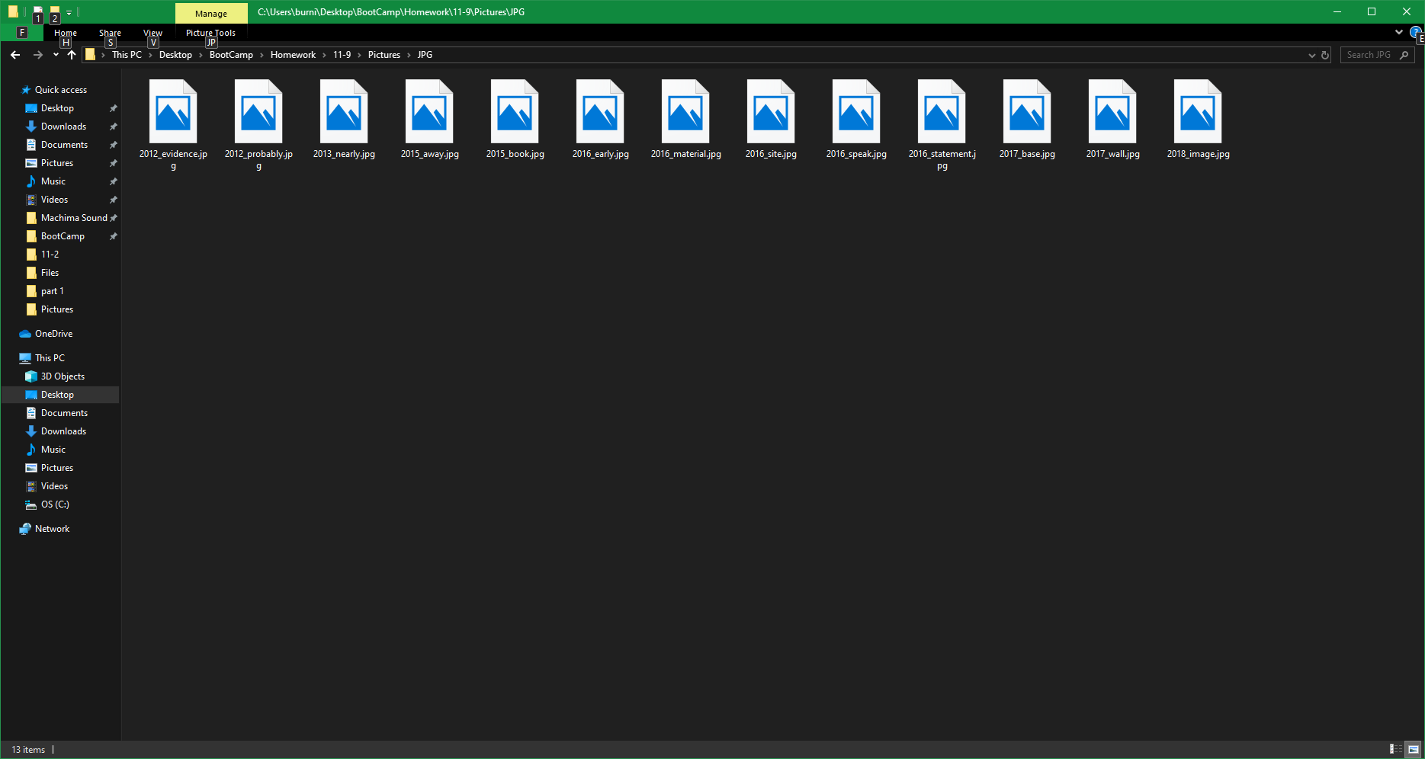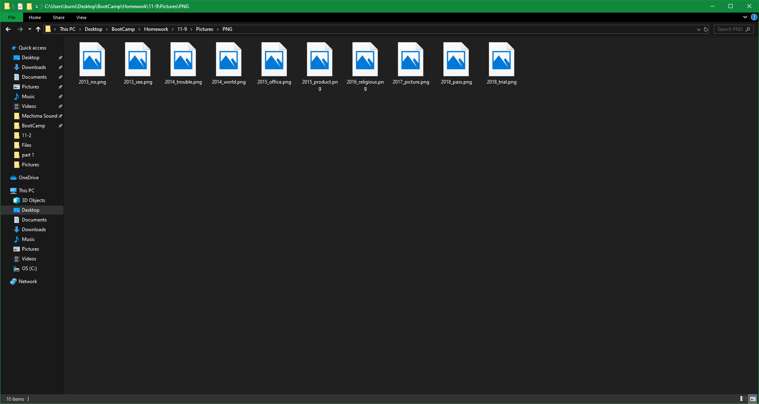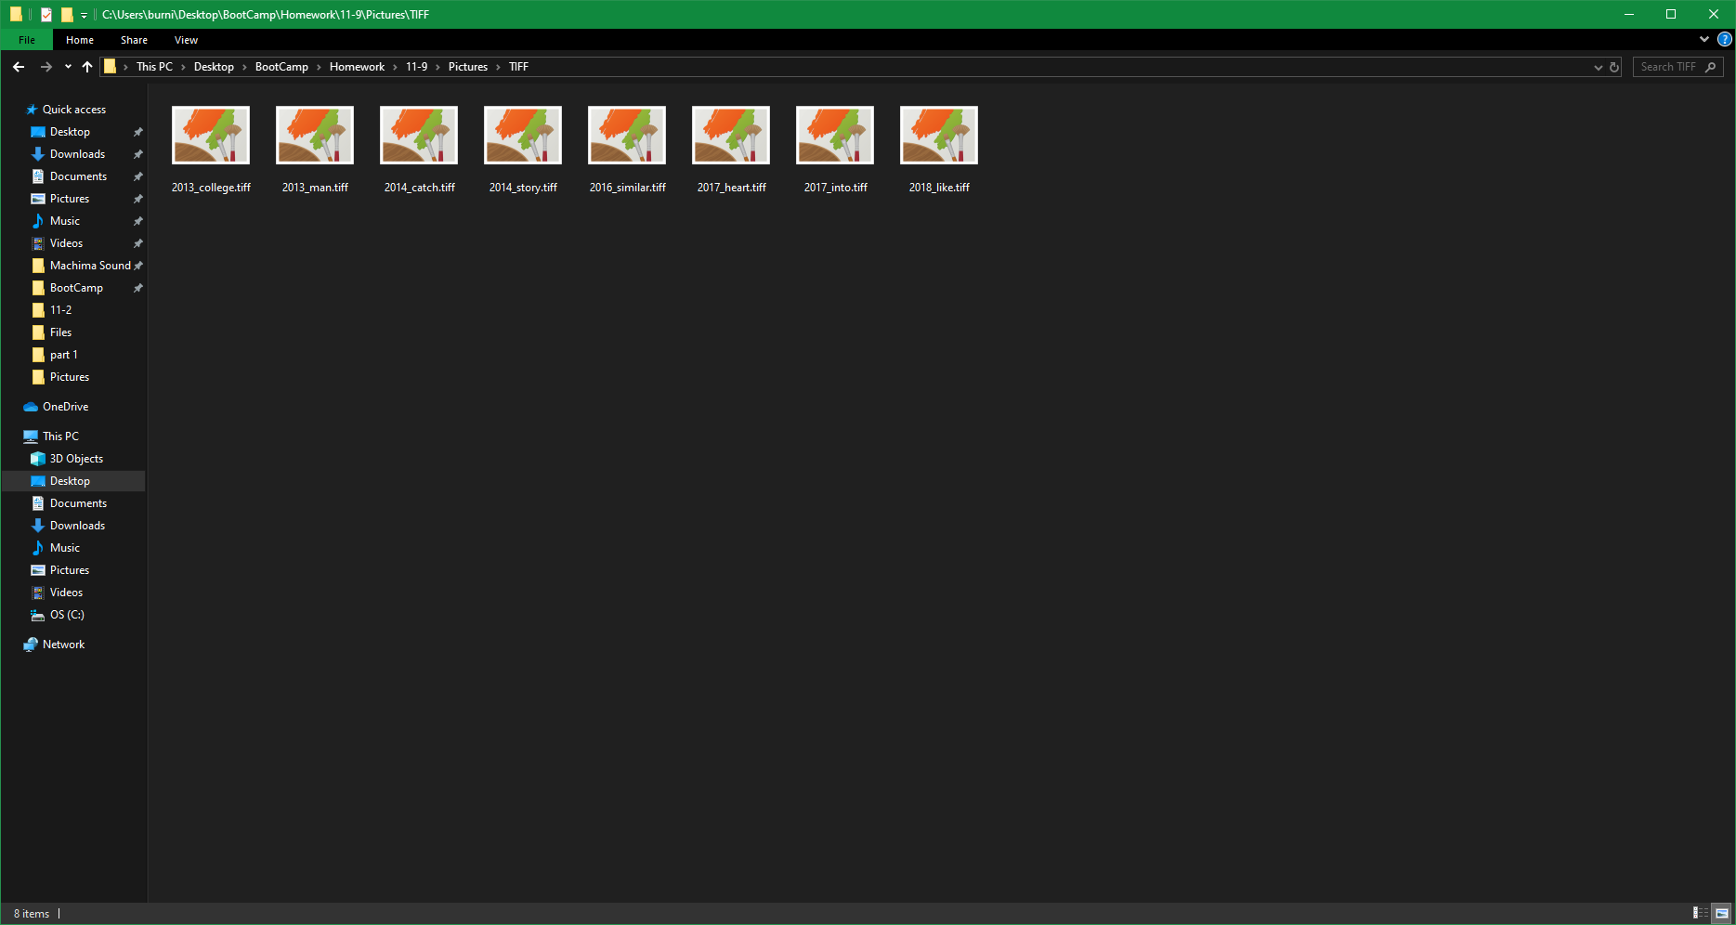

Display the PictureCounts.md file

Start the Picture.sh Script

Open the PictureCounts.md file

My directory structure after the script was run

All the .jpg’s in the JPG directory

All the .png’s in the PNG directory

All the .tiff’s in the tiff directory